VISVESVARAYA TECHNOLOGICAL UNIVERSITY
“JnanaSangama”, Belgaum -590014, Karnataka.

LAB REPORT
on

Object Oriented Java Programming (23CS3PCOOJ)
Submitted by
SHREYA SHAH (1BF24CS286)

in partial fulfillment for the award of the degree of
BACHELOR OF ENGINEERING
in

B.M.S. COLLEGE OF ENGINEERING
(Autonomous Institution under VTU)
BENGALURU-560019
Aug-2025 to Jan-2026

B.M.S. College of Engineering,
Bull Temple Road, Bangalore 560019
(Affiliated To Visvesvaraya Technological University, Belgaum)
Department of Computer Science and Engineering


CERTIFICATE

This is to certify that the Lab work entitled “Object Oriented Java Programming (23CS3PCOOJ)” carried out by SHREYA SHAH (1BF24CS286), who is bonafide student of B.M.S. College of Engineering. It is in partial fulfilment for the award of Bachelor of Engineering in Computer Science and Engineering of the Visvesvaraya Technological University, Belgaum. The Lab report has been approved as it satisfies the academic requirements in respect of an Object-Oriented Java Programming (23CS3PCOOJ) work prescribed for the said degree.

Dr. Seema Patil Associate Professor  Department of CSE, BMSCE | Dr. Kavitha Sooda Professor & HOD  Department of CSE, BMSCE

Index
Sl.  No. | Date | Experiment Title | Page No.
1 | 23/9/25 | Quadratic Equations | 4-5
2 | 13/10/25 | SGPA Calculator | 6-8
3 | 14/10/25 | BookStore Program | 9-11
4 | 4/11/25 | Shapes program | 12-14
5 | 4/11/25 | Bank Program | 15-20
6 | 18/11/25 | Packages | 21-24
7 | 26/11/25 | Errors | 25-27
8 | 9/12/25 | MultiThreading | 28-29
9 | 9/12/25 | Open Ended Question 1 | 30-31
10 | 9/12/25 | Open Ended Question 2 | 32-34

Github Link: https://github.com/Shrxyxz/1BF24CS286.JAVA

Program 1
Implement Quadratic Equation
Code:

import java.util.*; public class Quadratic
{
public static void main(String[] args ){ Scanner sc=new Scanner(System.in); double a,b,c,d;
System.out.println("Enter the value of a "); a= sc.nextInt();
System.out.println("Enter the value of b"); b= sc.nextInt();
System.out.println("Enter the value of c"); c= sc.nextInt();
if(a==0){
System.out.println("Not a quadratic equation");
}
else{
d=b*b-4*a*c; if(d==0){
double r1=(-b)/(2*a); System.out.println("Roots are real and equal"); System.out.println("roots"+r1);
}
else if (d>0) {
System.out.println("Roots are real and distinct"); double r1=((-b)+(Math.sqrt(d)))/(double)(2*a);
double r2=((-b)-(Math.sqrt(d)))/(double)(2*a); System.out.println("roots are "+r1); System.out.println("roots are"+r2);

}
else if(d<0){
System.out.println("Roots are imaginary"); double r1= (-b)/(2*a);

double r2= Math.sqrt(-d)/(2*a); System.out.println("roots are"+r1); System.out.println("roots are"+r2);
}
}
}
}

Terminal Output:
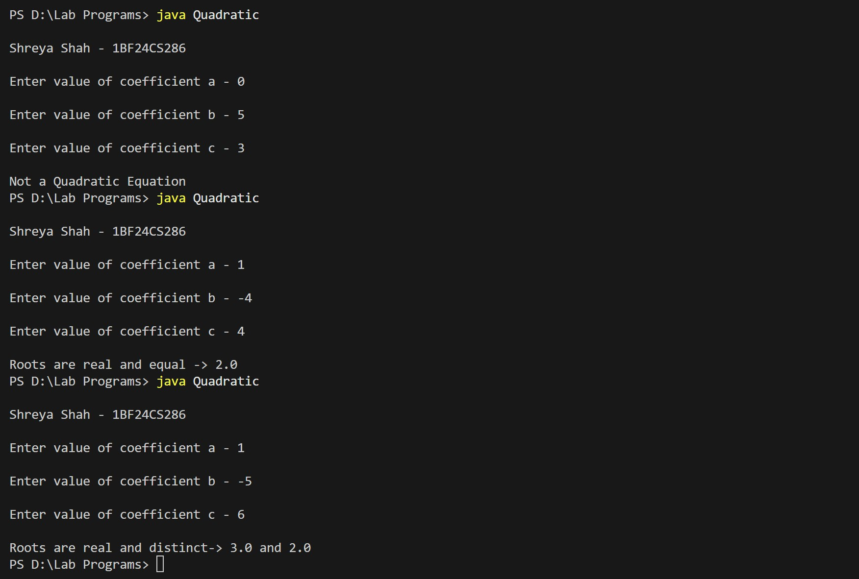

Program 2:
Implement SGPA Calculator
Code:
import java.util.Scanner;
class Student {
String usn; String name; int[] credits; int[] marks;

public void acceptDetails(Scanner sc) { System.out.print("Enter USN: "); usn = sc.nextLine();
System.out.print("Enter Name: "); name = sc.nextLine();
System.out.print("Enter number of subjects: "); int numSubjects = sc.nextInt();

credits = new int[numSubjects]; marks = new int[numSubjects];
for (int i = 0; i < numSubjects; i++) {
System.out.print("Enter credits for subject " + (i + 1) + ": "); credits[i] = sc.nextInt();

System.out.print("Enter marks for subject " + (i + 1) + ": "); marks[i] = sc.nextInt();
}
sc.nextLine();
}
public void displayDetails() { System.out.println("\nStudent Details:"); System.out.println("USN: " + usn); System.out.println("Name: " + name); for (int i = 0; i < credits.length; i++) {

System.out.println("Subject " + (i + 1) + " - Credits: " + credits[i] + ", Marks: " + marks[i]);
}
}

public double calculateSGPA() { double totalCredits = 0; double weightedSum = 0;

for (int i = 0; i < credits.length; i++) { int gradePoint;
if (marks[i] >= 90) {
gradePoint = 10;
} else if (marks[i] >= 80) { gradePoint = 9;
} else if (marks[i] >= 70) { gradePoint = 8;
} else if (marks[i] >= 60) { gradePoint = 7;
} else if (marks[i] >= 50) { gradePoint = 6;
} else if (marks[i] >= 40) { gradePoint = 5;
} else {
gradePoint = 0;
}
weightedSum += gradePoint * credits[i]; totalCredits += credits[i];
}

if (totalCredits == 0) return 0;
return weightedSum / totalCredits;
}
}
public class StudentSGPACalculator { public static void main(String[] args) {

Scanner sc = new Scanner(System.in); Student student = new Student(); student.acceptDetails(sc); student.displayDetails();
double sgpa = student.calculateSGPA(); System.out.printf("SGPA of the student: %.2f\n", sgpa);
sc.close(); // Close scanner to avoid resource leak
}
}

Terminal Output:

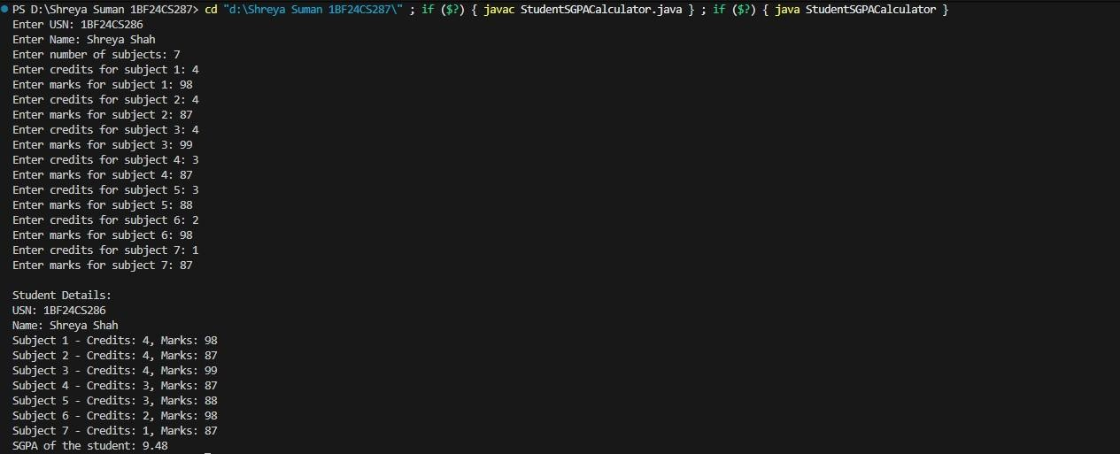

Lab Program 3:
Implement Bookstore Management
Code:
import java.util.Scanner;
class Book { String name; String author; int price;
int numPages;

Book(String name, String author, int price, int numPages) { this.name = name;
this.author = author; this.price = price; this.numPages = numPages;
}

public String toString() {
return "Book Name: " + name + "\n"
+ "Author Name: " + author + "\n"
+ "Price: " + price + "\n"
+ "Number of Pages: " + numPages + "\n";
}
}
public class BookStore {
public static void main(String[] args) { Scanner s = new Scanner(System.in); System.out.print("Enter number of books: "); int n = s.nextInt();
Book[] books = new Book[n]; for (int i = 0; i < n; i++) {

System.out.println("\nEnter details for Book " + (i + 1) + ":"); s.nextLine();

System.out.print("Name: "); String name = s.nextLine();

System.out.print("Author: "); String author = s.nextLine();
System.out.print("Price: "); int price = s.nextInt();

System.out.print("Number of pages: "); int numPages = s.nextInt();
books[i] = new Book(name, author, price, numPages);
}
System.out.println("\n--- Book Details ---"); for (Book b : books) {
System.out.println(b.toString());
}
s.close();
}
}

Terminal Output:

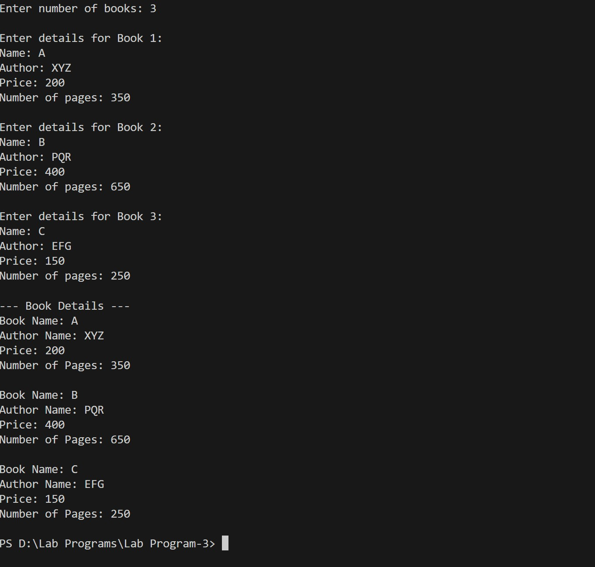

Lab Program 4:
Implement a program to calculate attributes of different shapes
Code:
import java.util.Scanner;
abstract class Shape { protected int dim1; protected int dim2;

public abstract void printArea();
}

class Rectangle extends Shape {
public Rectangle(int length, int width) { this.dim1 = length;
this.dim2 = width;
}

@Override
public void printArea() { int area = dim1 * dim2;
System.out.println("Area of Rectangle: " + area);
}
}

class Triangle extends Shape {

public Triangle(int base, int height) { this.dim1 = base;
this.dim2 = height;
}

@Override
public void printArea() {
// Use 0.5 to ensure floating-point calculation

double area = 0.5 * dim1 * dim2; System.out.println("Area of Triangle: " + area);
}
}

class Circle extends Shape { public Circle(int radius) {
this.dim1 = radius;
}

@Override
public void printArea() {
double area = Math.PI * dim1 * dim1;

System.out.printf("Area of Circle: %.2f\n", area);
}
}

public class Shapes {
public static void main(String[] args) { Scanner sc = new Scanner(System.in);
// Rectangle input
System.out.println("Enter dimensions for Rectangle:"); System.out.print("Enter length: ");
int length = sc.nextInt(); System.out.print("Enter width: "); int width = sc.nextInt();
Shape rectangle = new Rectangle(length, width);
// Triangle input
System.out.println("\nEnter dimensions for Triangle:"); System.out.print("Enter base: ");

int base = sc.nextInt(); System.out.print("Enter height: "); int height = sc.nextInt();
Shape triangle = new Triangle(base, height);

// Circle input
System.out.println("\nEnter dimensions for Circle:"); System.out.print("Enter radius: ");
int radius = sc.nextInt();
Shape circle = new Circle(radius);

System.out.println("\n--- Areas of Shapes ---"); rectangle.printArea();
triangle.printArea(); circle.printArea();
sc.close();
}
}
Terminal Output:
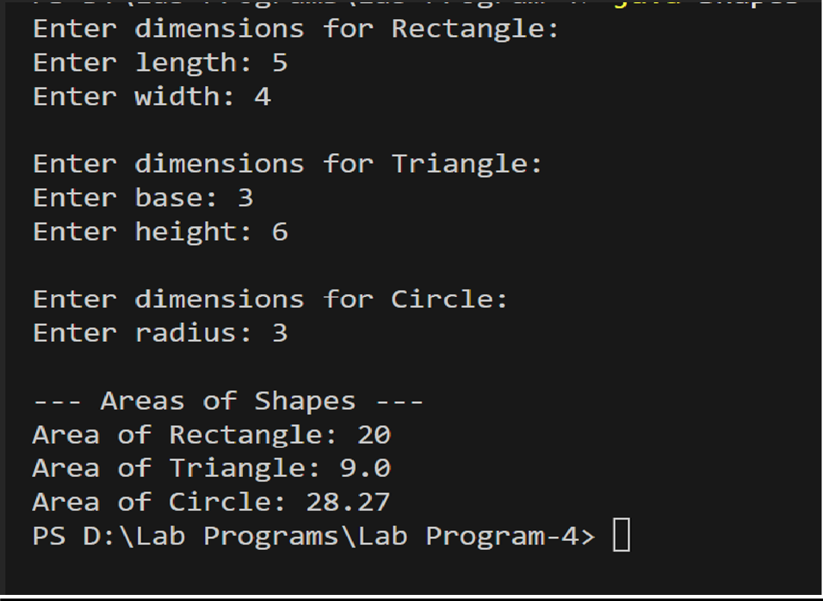

Lab Program 5:
Implement a program for a banking software.

Code:
import java.util.Scanner;
class Account
{
String customerName; String accountNumber; String accountType; double balance;

Account(String customerName, String accountNumber, String accountType, double initialBalance) {
this.customerName = customerName; this.accountNumber = accountNumber; this.accountType = accountType; this.balance = initialBalance;
}
void deposit(double amount)
{
if (amount > 0)
{
balance += amount; System.out.println("Deposited: " + amount);
}
else
{
System.out.println("Invalid deposit amount.");
}
}

void displayBalance() {
System.out.println("Current Balance: " + balance);
}
}

class Saving extends Account
{
double INTEREST_RATE = 0.05;
Saving(String customerName, String accountNumber, double initialBalance)
{
super(customerName, accountNumber, "Savings", initialBalance);
}
void Interest(int years) {
double interest = balance * Math.pow((1 + INTEREST_RATE), years) - balance; balance += interest;
System.out.println("Interest of " + String.format("%.2f", interest) + " added to your account.");
}
void withdraw(double amount)
{
if (amount <= balance)
{
balance -= amount; System.out.println("Withdrawn:" + amount);
} else
{
System.out.println("Insufficient balance!");
}
}
}
class Current extends Account {
static final double MIN_BALANCE = 1000.0; static final double SERVICE_CHARGE = 50.0;
public Current(String customerName, String accountNumber, double initialBalance)
{
super(customerName, accountNumber, "Current", initialBalance);
}

void withdraw(double amount) { if (amount <= balance) {
balance -= amount;

System.out.println("Withdrawn: ₹" + amount); checkMinimumBalance();
} else {
System.out.println("Insufficient balance!");
}
}
void checkMinimumBalance() {
if (balance < MIN_BALANCE) { balance -= SERVICE_CHARGE;
System.out.println("Balance below minimum! Service charge of ₹" + SERVICE_CHARGE + " imposed.");
}
}
}
public class Banking {
public static void main(String[] args) { Scanner in = new Scanner(System.in);
System.out.println("Enter Customer Name:"); String name = in.nextLine();

System.out.println("Enter Account Number:"); String accNo = in.nextLine();
System.out.println("Enter Account Type (savings/current):"); String type = in.nextLine().toLowerCase();

System.out.println("Enter Initial Balance:"); double balance = in.nextDouble();
Account account;
if (type.equals("savings"))
{
account = new Saving(name, accNo, balance);
}
else
{

account = new Current(name, accNo, balance);
}
int choice; do {
System.out.println("\nOptions Available"); System.out.println("1. Deposit"); System.out.println("2. Withdraw"); System.out.println("3. Display Balance"); if (account instanceof Saving)
System.out.println("4. Compute and Deposit Interest"); System.out.println("5 . Exit");
System.out.print("Enter choice: "); choice = in.nextInt();
switch (choice) { case 1:
System.out.print("Enter amount to deposit: "); double depositAmount = in.nextDouble(); account.deposit(depositAmount);
break;

case 2:
System.out.print("Enter amount to withdraw: "); double withdrawAmount = in.nextDouble();
if (account instanceof Saving) {
((Saving) account).withdraw(withdrawAmount);
} else {
((Current) account).withdraw(withdrawAmount);
}
break;
case 3:
account.displayBalance(); break;
case 4:
if (account instanceof Saving) {
System.out.print("Enter number of years for interest: "); int years = in.nextInt();

Account.");
((Saving) account).Interest(years);
} else {
System.out.println("Interest computation not available for Current

}
break;
case 5:
System.out.println("Exiting Program "); break;
default:
System.out.println("Invalid choice. Try again.");
}
} while (choice != 0);

in.close();
}
}
Terminal Output:

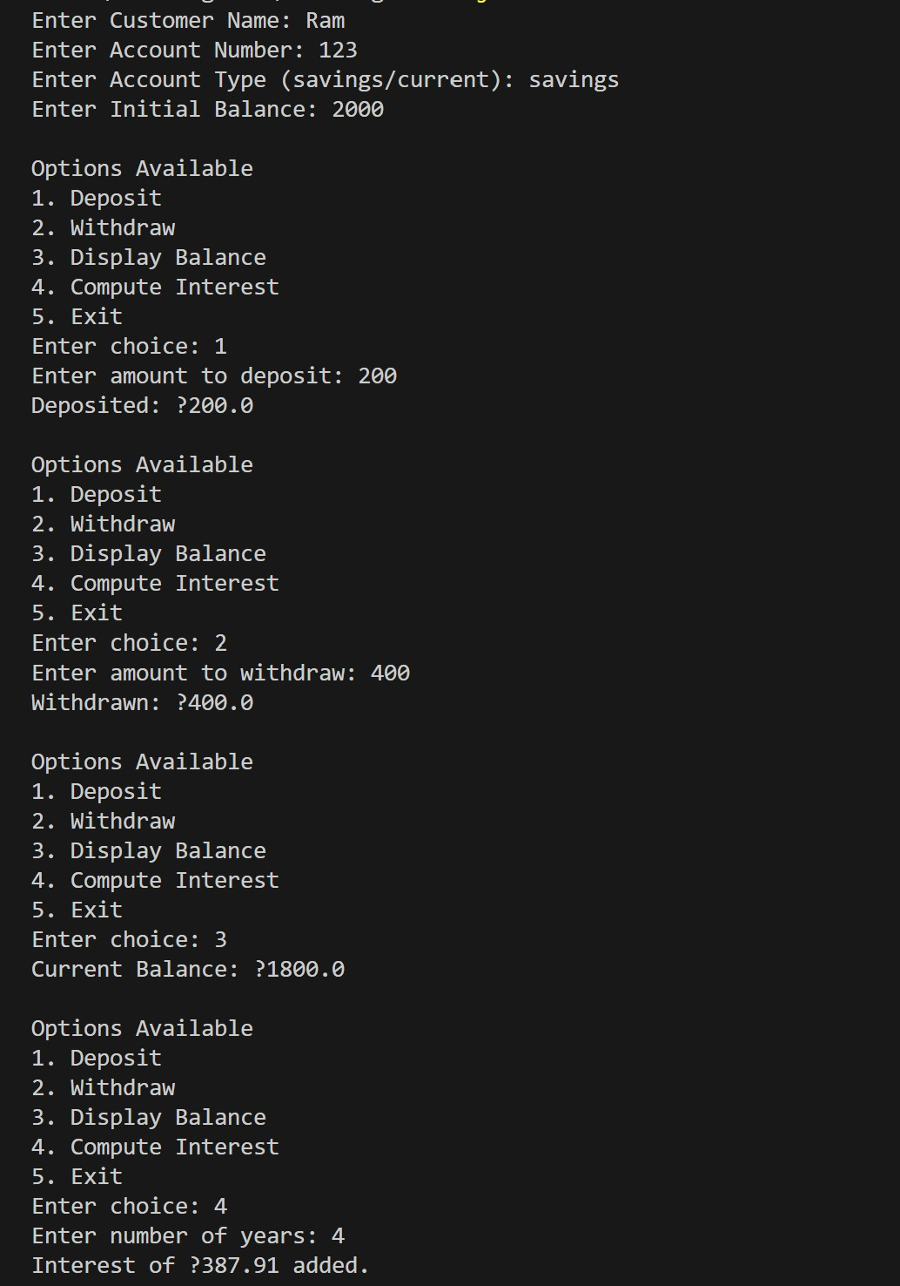

Lab Program 6
Implement a program to show packages in java
Code:
Package CIE Programs:
1.
package CIE;
import java.util.Scanner;

public class Internals extends Student { protected int marks[] = new int[5];
public void inputCIEmarks() {
Scanner in = new Scanner(System.in); System.out.println("Enter CIE marks for 5 subjects:"); for (int i = 0; i < 5; i++) {
System.out.print("CIE Mark " + (i + 1) + ": "); marks[i] = in.nextInt();
}
}
}
2.
package CIE;
import java.util.Scanner; public class Student {
protected String usn; protected String name; protected int sem;

public void inputStudentDetails() { Scanner in = new Scanner(System.in); System.out.print("Enter USN: ");
usn = in.nextLine(); System.out.print("Enter Name: "); name = in.nextLine(); System.out.print("Enter Semester: ");

sem = in.nextInt();
}
public void displayStudentDetails() { System.out.println("USN: " + usn); System.out.println("Name: " + name); System.out.println("Semester: " + sem);
}
}

Package SEE Program:
package SEE;
import CIE.Internals; import java.util.Scanner;
public class Externals extends Internals { protected int marksSEE[];
protected int finalMarks[];
public Externals() { marksSEE = new int[5]; finalMarks = new int[5];
}
public void inputSEEmarks() {
Scanner s = new Scanner(System.in); System.out.println("Enter SEE marks for 5 subjects:"); for (int i = 0; i < 5; i++) {
System.out.print("SEE Mark " + (i + 1) + ": "); marksSEE[i] = s.nextInt();
}
}
public void calculateFinalMarks() { for (int i = 0; i < 5; i++) {
finalMarks[i] = marks[i] + marksSEE[i];
}
}

public void displayFinalMarks() { displayStudentDetails(); System.out.println("Final marks (CIE + SEE):"); for (int i = 0; i < 5; i++) {
System.out.println("Subject " + (i + 1) + ": " + finalMarks[i]);
}
}
}
Main Program:
import SEE.Externals;
class Main {
public static void main(String args[]) { int n = 0;
java.util.Scanner s = new java.util.Scanner(System.in);

System.out.print("Enter number of students: "); n = s.nextInt();
Externals arr[] = new Externals[n]; for (int i = 0; i < n; i++) {
System.out.println("\nEnter details of student " + (i + 1));
arr[i] = new Externals(); arr[i].inputStudentDetails(); arr[i].inputCIEmarks(); arr[i].inputSEEmarks(); arr[i].calculateFinalMarks();
}

System.out.println("\nFINAL MARKS "); for (int i = 0; i < n; i++) {
System.out.println("\nStudent " + (i + 1) + ":"); arr[i].displayFinalMarks();
}
}
}

Terminal Output:

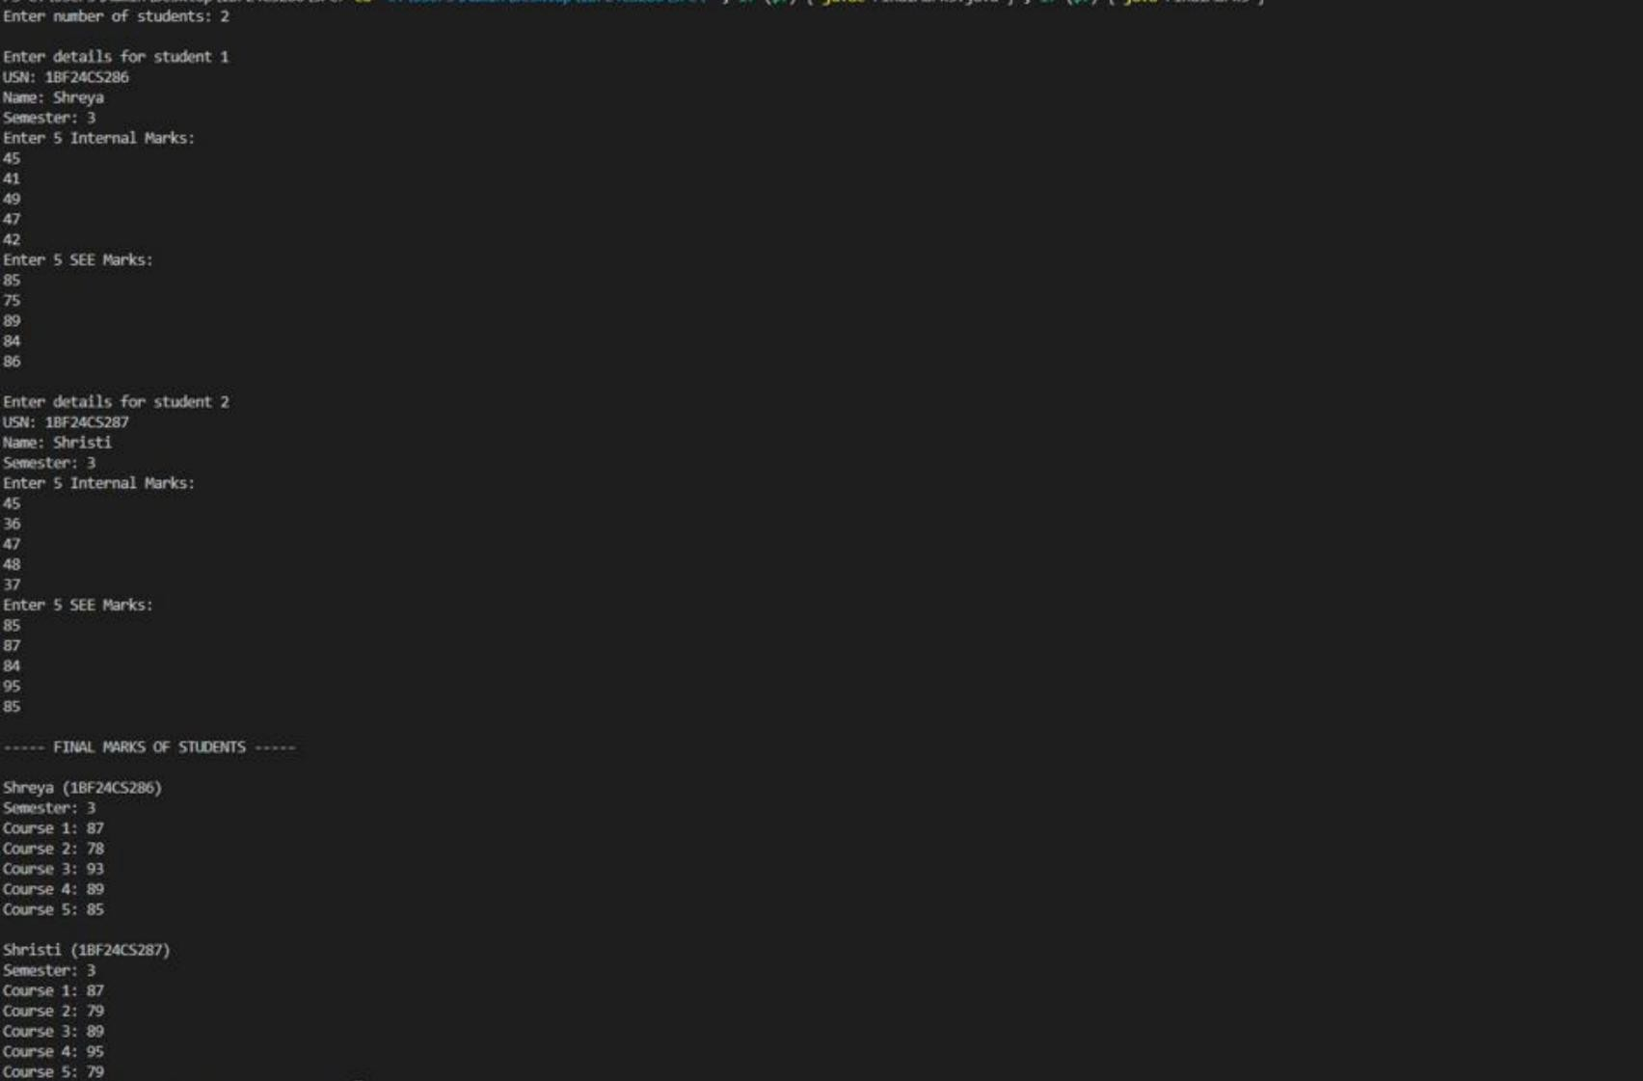

Lab Program 7
Implement a Java Program to show Error Handling
Code:
import java.util.Scanner;
class WrongAge extends Exception
{
public WrongAge(String message)
{
super(message);
}
}
class Father
{
int fatherAge;

Father(int age) throws WrongAge
{
if (age<0)
{
throw new WrongAge("Father's age cannot be negative!");
}
this.fatherAge = age;
}
void display()
{
System.out.println("Father's age : "+fatherAge);
}
}

class Son extends Father{ int sonAge;
Son(int fatherAge,int sonAge) throws WrongAge
{
super(fatherAge);

if (sonAge>=fatherAge)
{
throw new WrongAge (
"Son's age cannot be greater than or equal to father's age!"
);
}
if (sonAge<0)
{
throw new WrongAge("Son's age cannot be negative!");
}
this.sonAge=sonAge;
}
}
public class Error
{
public static void main(String[] args)
{
Scanner in = new Scanner(System.in); int s_age,f_age;
System.out.println("Enter father's age : "); f_age = in.nextInt(); System.out.println("Enter son's age : "); s_age = in.nextInt();
try{
Son s = new Son(f_age,s_age);
System.out.println("Father and Son objects created successfully!"); s.display();
}
catch(WrongAge e)
{
System.out.println("Wrong Age Error: " + e.getMessage());
}
}
}

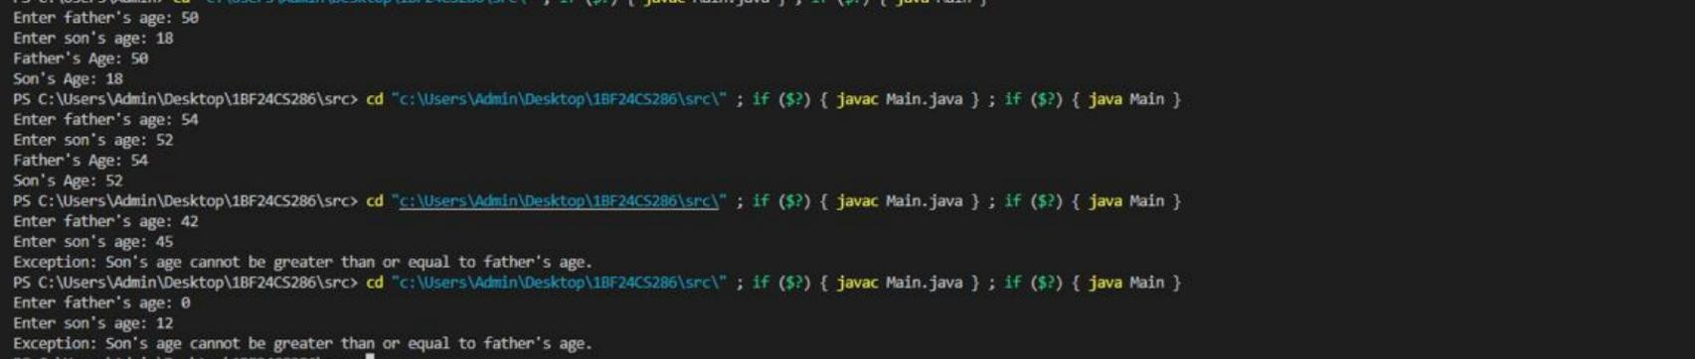
Terminal Output:

Lab Program 8
Implement a Java Program to show working of Threads
Code:
class MessageThread extends Thread { private String message;
private int interval;

MessageThread(String message, int interval) { this.message = message;
this.interval = interval;
}
public void run() { try {
while (true) { System.out.println(message); Thread.sleep(interval);
}
} catch (InterruptedException e) { System.out.println("Thread interrupted.");
}
}
}
public class Threads {
public static void main(String[] args) {
MessageThread t1 = new MessageThread("BMS College of Engineering", 10000);
MessageThread t2 = new MessageThread("CSE", 2000);
t1.start();
t2.start();
}
}

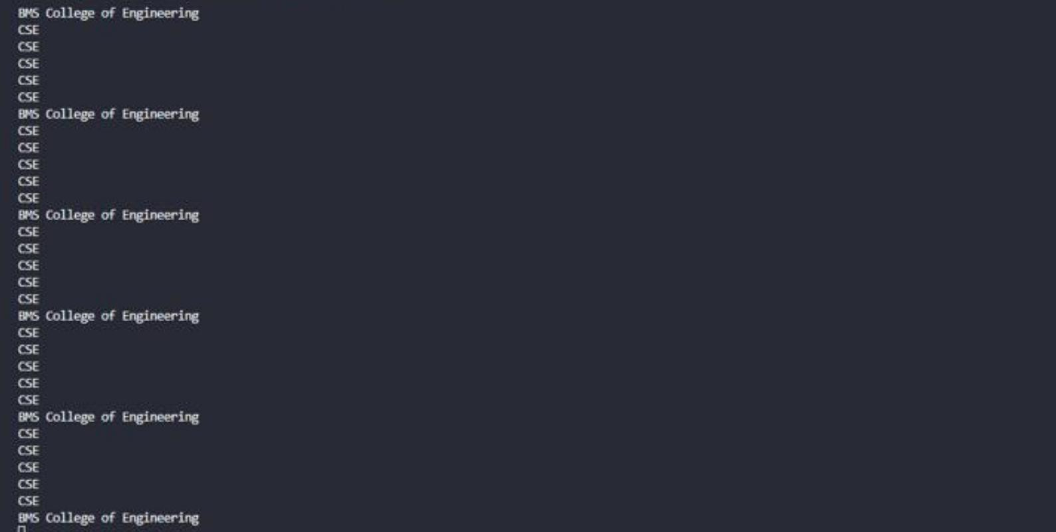
Terminal Output:

Lab Program 9
Open Ended Question 1
Code:
import javax.swing.*; import java.awt.*; import java.awt.event.*;
public class DivisionUI {
public static void main(String[] args) {

JFrame frame = new JFrame("Integer Division"); frame.setSize(350, 200); frame.setDefaultCloseOperation(JFrame.EXIT_ON_CLOSE); frame.setLayout(new GridLayout(4, 2));
JLabel l1 = new JLabel("Num1:"); JTextField t1 = new JTextField();
JLabel l2 = new JLabel("Num2:"); JTextField t2 = new JTextField();

JLabel l3 = new JLabel("Result:"); JTextField result = new JTextField(); result.setEditable(false);
JButton divideBtn = new JButton("Divide"); divideBtn.addActionListener(new ActionListener() {
public void actionPerformed(ActionEvent e) { try {
int num1 = Integer.parseInt(t1.getText()); int num2 = Integer.parseInt(t2.getText());
int res = num1 / num2; result.setText(Integer.toString(res));
}
catch (NumberFormatException ex) { JOptionPane.showMessageDialog(frame,
"Please enter valid integers!",

"Number Format Error", JOptionPane.ERROR_MESSAGE);
}
catch (ArithmeticException ex) { JOptionPane.showMessageDialog(frame,
"Division by zero is not allowed!", "Arithmetic Error", JOptionPane.ERROR_MESSAGE);
}
}
});
frame.add(l1); frame.add(t1); frame.add(l2); frame.add(t2); frame.add(l3); frame.add(result); frame.add(divideBtn);
frame.setVisible(true);
}
}
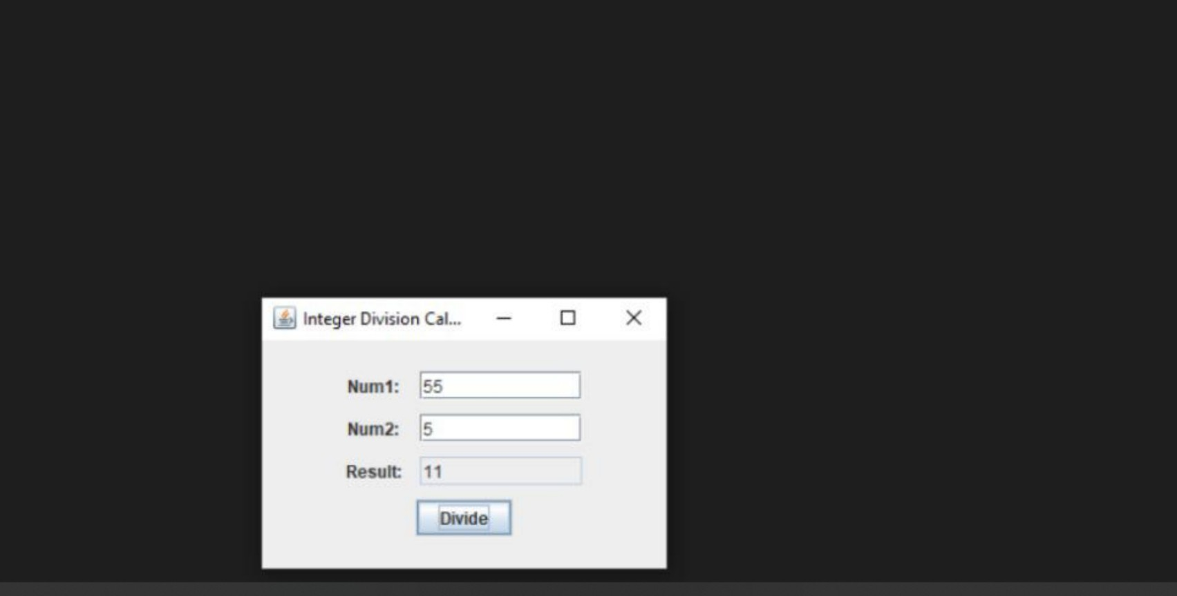
Terminal Output:

Lab Program 10:
Open Ended Question 2
Code:
class Q { int n;
boolean valueSet = false;

synchronized int get() { while (!valueSet) {
try {
System.out.println(" Consumer waiting"); wait();
} catch (InterruptedException e) { System.out.println("InterruptedException caught");
}
}

System.out.println("Got: " + n); valueSet = false;
System.out.println("Intimate Producer"); notify();
return n;
}

synchronized void put(int n) { while (valueSet) {
try {
System.out.println("Producer waiting"); wait();
} catch (InterruptedException e) { System.out.println("InterruptedException caught");
}
}
this.n = n; valueSet = true;
System.out.println("Put: " + n);

System.out.println("Intimate Consumer"); notify();
}
}

class Producer implements Runnable { Q q;
Producer(Q q) { this.q = q;
new Thread(this, "Producer").start();
}
public void run() { int i = 0;
while (i < 3) { q.put(i++);
}
}
}
class Consumer implements Runnable { Q q;

Consumer(Q q) { this.q = q;
new Thread(this, "Consumer").start();
}

public void run() { int i = 0;
while (i < 3) { int r = q.get();
System.out.println("Consumed: " + r); i++;
}
}
}
public class PCDemo {

public static void main(String[] args) { Q q = new Q();
new Producer(q); new Consumer(q);
}
}
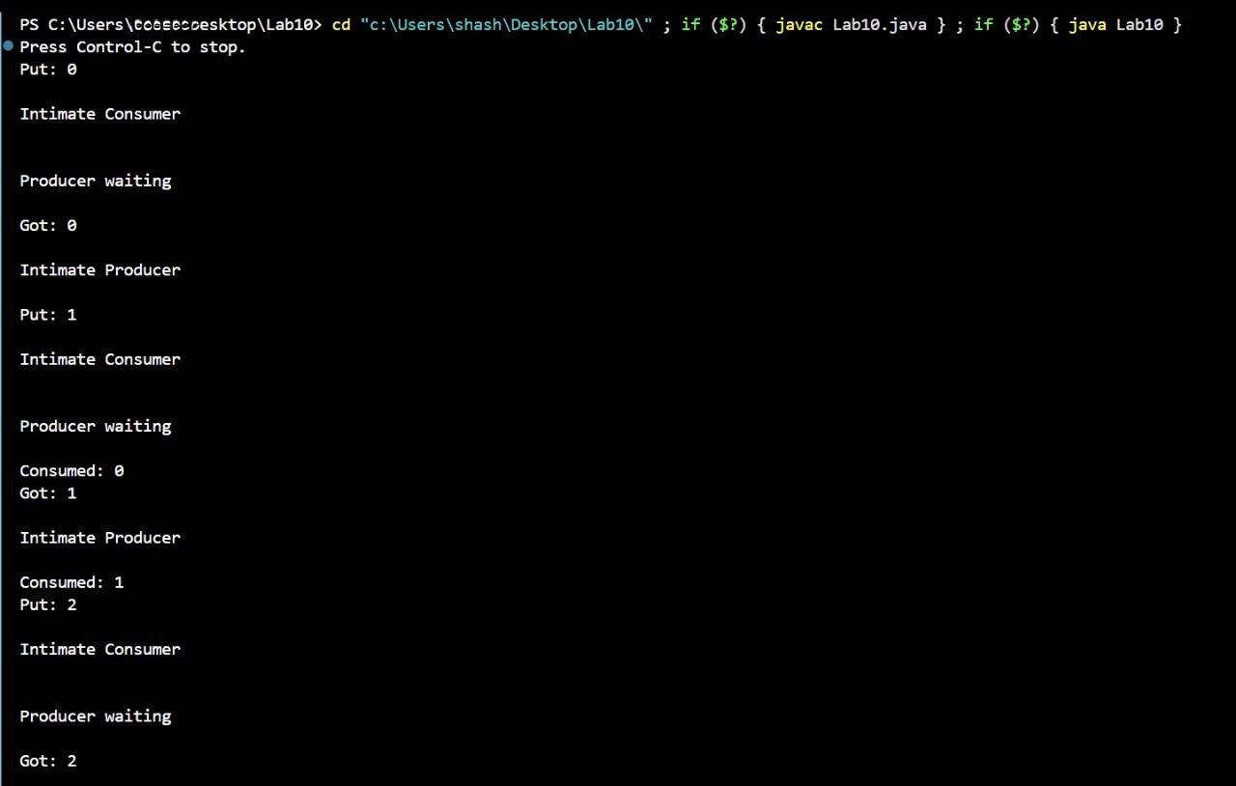
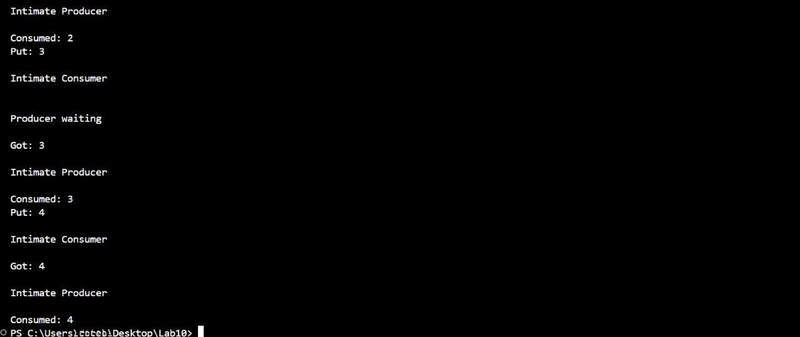
Terminal Ouput:

